Parks and Playgrounds
FAIRBANKS AREA Legend: =water nearby =fenced

Baranof Park  525 Baranof Avenue  https://fairbanksak.myrec.com/info/facilities/details.aspx?FacilityID=14741  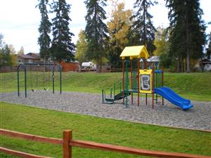 | Birch Hill Rec Area  101 Wilderness Drive  https://fairbanksak.myrec.com/info/facilities/details.aspx?FacilityID=14701  No playground equipment, just a large field to run in.  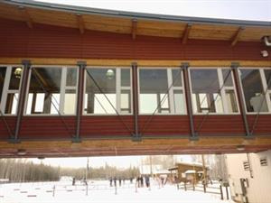
Bluebell Park
1555 Bluebell Street
https://fairbanksak.myrec.com/info/facilities/details.aspx?FacilityID=14751
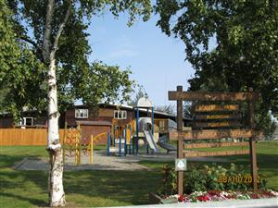

Chena Kiwanis Park  4525 Chena Small Tracts Rd.  https://fairbanksak.myrec.com/info/facilities/details.aspx?FacilityID=14754  In very close proximity to the Chena River. Very woodsy as well.  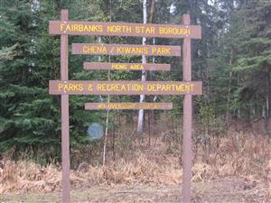 | Fahrenkamp Park  4004 Fahrenkamp Ave  https://fairbanksak.myrec.com/info/facilities/details.aspx?FacilityID=14853
Fairbanks Lions Recreation Area  1486 Hampstead Ave  https://fairbanksak.myrec.com/info/facilities/details.aspx?FacilityID=14854  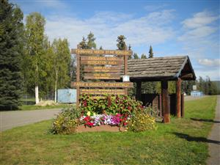 | Fun Time Park  3440 Shanley Street  https://fairbanksak.myrec.com/info/facilities/details.aspx?FacilityID=14855  Near Hot Licks off of College Rd  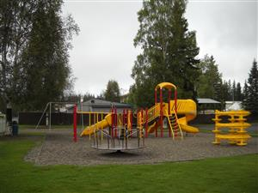
Graehl Park  301 Front Street  https://fairbanksak.myrec.com/info/facilities/details.aspx?FacilityID=14856  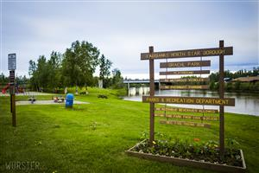 | Griffin Park  360 Wendell Ave  https://fairbanksak.myrec.com/info/facilities/details.aspx?FacilityID=14857  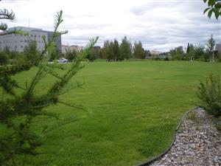
Growden Park  207 Wilbur Street  https://fairbanksak.myrec.com/info/facilities/details.aspx?FacilityID=14858  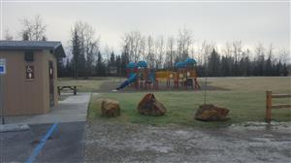  By the baseball fields and The Carlson Center. | Hamilton Acres Park  101 hamilton Avenue  https://fairbanksak.myrec.com/info/facilities/details.aspx?FacilityID=14924  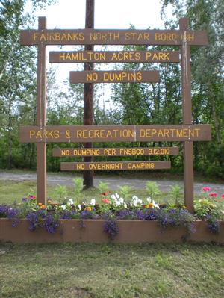
Janel Thompson Park  1701 2nd Avenue  https://fairbanksak.myrec.com/info/facilities/details.aspx?FacilityID=14923  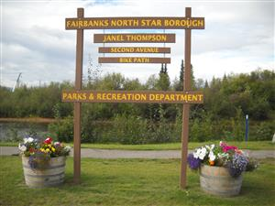 | Kiana Park  1802 Kiana Street  https://fairbanksak.myrec.com/info/facilities/details.aspx?FacilityID=14863  In the neighborhood behind Value Village
Kiwanis Park  2019 2nd Avenue  https://fairbanksak.myrec.com/info/facilities/details.aspx?FacilityID=14864  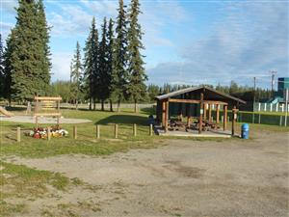 | Mercier Park  823 22nd Avenue  https://fairbanksak.myrec.com/info/facilities/details.aspx?FacilityID=14868  Off of South Cushman, near the Holiday Gas Station
Midnight Sun Lions Park  770 15th Avenue  https://fairbanksak.myrec.com/info/facilities/details.aspx?FacilityID=14869  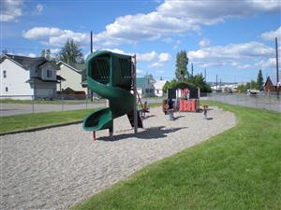 | Myrtle Thomas Park  323 12th Avenue  https://fairbanksak.myrec.com/info/facilities/details.aspx?FacilityID=14874  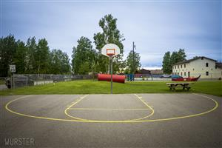
Nussbaumer Park  510 Iditarod Ave  https://fairbanksak.myrec.com/info/facilities/details.aspx?FacilityID=14878 | Pioneer Park  2300 Airport Way  https://fairbanksak.myrec.com/info/facilities/details.aspx?FacilityID=14699
Slaterville Park  341 Slater Street  https://fairbanksak.myrec.com/info/facilities/details.aspx?FacilityID=14879  Weeks Field/Wien Park  805 Smythe Street  https://fairbanksak.myrec.com/info/facilities/details.aspx?FacilityID=14885  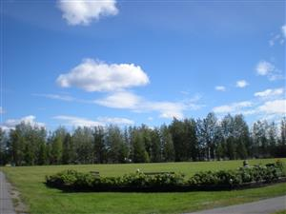 | Snedden Memorial Park  368 Slater Drive  https://fairbanksak.myrec.com/info/facilities/details.aspx?FacilityID=14880  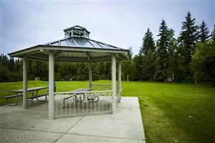  Sunrisers Rotary Playground  1912 Twenty-Fifth Ave  This is an Accessible Playground  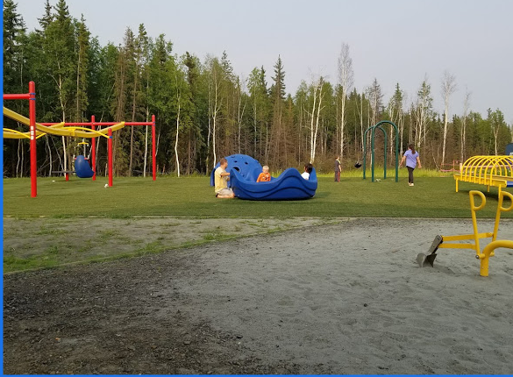
ELEMENTARY SCHOOLS
Anne Wien: 1501 Hampstead Ave. Across from the Cookie Jar Restaurant | Ladd: 601 F St.
Arctic Light: On Ft.WW, must have pass | Nordale: 397 Hamilton Ave
Barnette: 725 10th Ave Downtown | Pearl Creek: 700 Auburn Dr. Off of Farmers Loop
Denali: 1042 Lathrop Street | University Park: 554 Loftus Rd. Close to UAF
Hunter: 1630 Gilliam Way Close to FMH | Weller: 635 Elementary Dr. Chena Hot springs Rd
Joy: 24 Margaret Ave Off of College Rd, Costco end | Woodriver: 5000 Palo Verde Ave University West

Parks and Playgrounds
NORTH POLE AREA Legend: =water nearby =fenced

5th Avenue Park  275 5th Ave  https://fairbanksak.myrec.com/info/facilities/details.aspx?FacilityID=14875  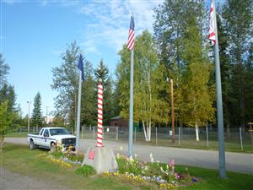 | Chena Lakes Recreation Area  3779 Laurance Rd  https://fairbanksak.myrec.com/info/facilities/details.aspx?FacilityID=14703  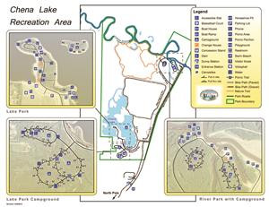
Kendall Park  1810 Kendall Avenue  https://fairbanksak.myrec.com/info/facilities/details.aspx?FacilityID=14862  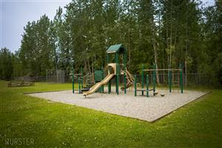 | Elementary School:  Ticasuk Brown: 785 Lakloey Drive  Midnight Sun Elementary:

