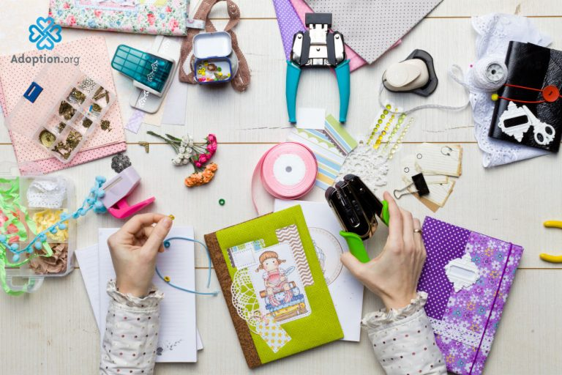

LifeBooks
What do I need for a Lifebook
To start:
- 1 in 3 ring binder
- 40 Sheet projectors
- 1 Thumb Drive
- Pencils and a pencil pouch
- Glue stick or tape
- Printer and paper for Lifebook pages
- Creative brain!
What is a Lifebook?
Lifebooks are created to help children tell their stories. It is a tool used in adoption and fostering care; it allows the child to confirm their existence visually. It provides the opportunity for communication, which helps to build trust, connection, and attachment. It is also an excellent opportunity for a child to express grief and loss. Creating a Lifebook can be therapeutic. It encourages a child to understand their chronological story and address grief and loss, separation from family, unique cultural issues, and emotions.

